**Experiment no. 01**

* 1. **Experiment Name**

To get familiar with the equipment’s of communication lab

* 1. **Objectives**
* To get acquainted with the operation of the AM and FM Transmitter and Receiver Kit
* To get familiar with line code encoder and decoder, and their kit functions
* To become accustomed with the modulation and demodulation circuitry, such as ADM, ASK, PSK, PWM, PCM, DM, FSK modulator and demodulator, and their kit functions
  1. **Theory**

The process of encoding information in a signal is referred to as modulation. Similarly, the process of retrieving information from a transmitted signal is referred to as demodulation. Modulation and demodulation are critical in the telecommunications industry.

In the telecommunications system, many modulations, demodulations, and transmission devices or apparatuses were developed. Among these, the following were introduced in this experiment as a learning process.

**1.3.1 Amplitude modulation (AM) transmitter & demodulation (ADM) receiver**

Amplitude modulation (AM) transmitter is defined as a technique used in electrical communication to transfer messages via a radio wave. The wave's amplitude varies in proportion to the message signal, such as an audio signal. The practical application includes portable two-way radios, citizen band radio, VHF aviation radio, and computer modems.

Amplitude demodulation (ADM) receiver, on the other hand is used for opposite of an AM transmitter. ADM is the process by which the original information bearing modulation signal, is extracted from the overall received incoming signal.

Demodulation of amplitude modulated signals can be accomplished in a variety of ways, each with its own set of advantages.

Amplitude demodulation receiver can be found in broadcast receivers, professional radio communication equipment, and walkie talkies—AM is still utilized for air-band radio communications.

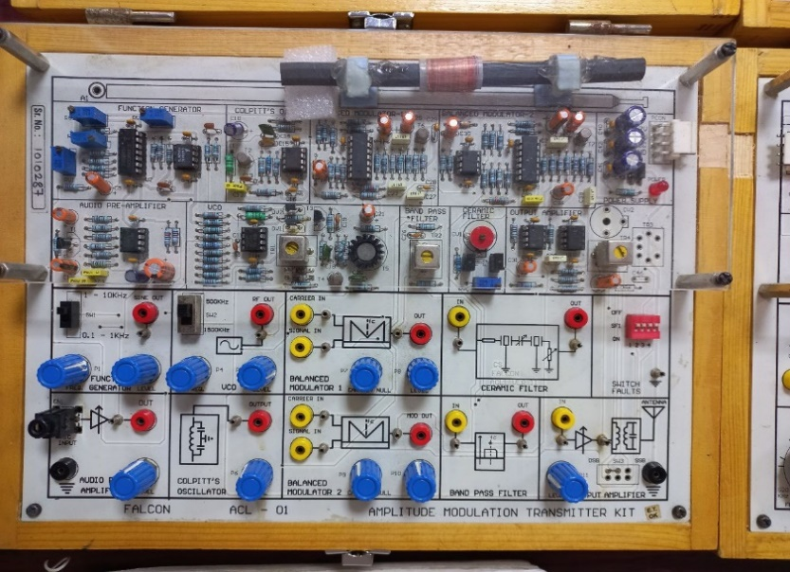 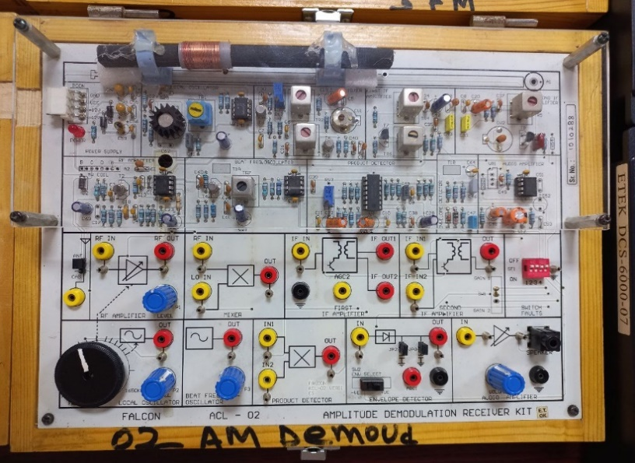

Fig.1.1: Amplitude modulation transmitter kit Fig.1.2: Amplitude demodulation receiver kit

**1.3.2 Frequency modulation (FM) transmitter & demodulation (FDM) receiver**

Frequency modulation is defined as the process of encoding information in a carrier wave by altering the wave's instantaneous frequency. The difference between the carrier frequency and its center frequency, has a functional relationship to the modulating signal amplitude in analog frequency modulation, such as radio broadcasting of an audio signal representing voice or music.

A frequency modulation transmitter is a very high frequency (VHF) Colpitts oscillator capable of transmitting sound to standard FDM receiver.

FM demodulation is a critical step in receiving a frequency modulated transmission. After the signal has been received, filtered, and amplified, the original modulation from the carrier must be recovered.

Telecommunications, radio transmission, signal processing, and computers all employ the technology.

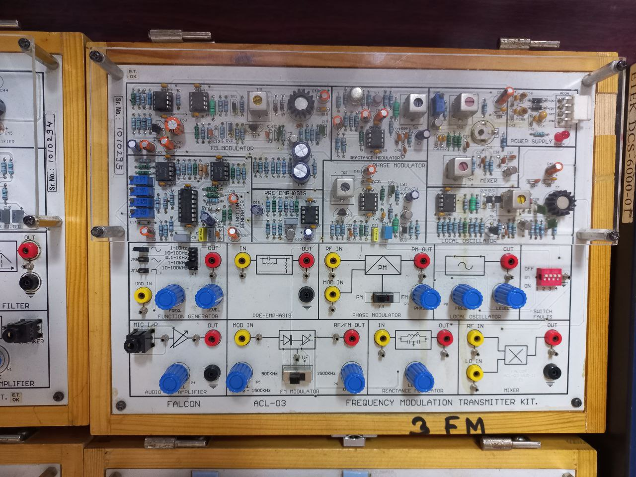 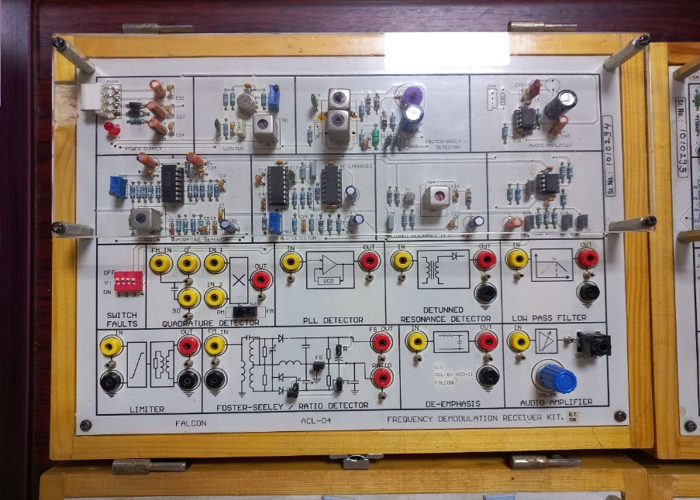

Fig.1.3: Frequency modulation transmitter kit Fig.1.4: Frequency demodulation receiver kit

**1.3.3 Line code encoder & decoder**

The line code encoder provides as an interface between the transmitter's TTL level signals and those of the analog channel. Similarly, the line code decoder acts as a bridge between the channel's analog signals and the TTL level signals required by the digital receiver.

**1.3.4 PWM modulator & demodulator**

PWM, or pulse width modulation, is a modulation process or technique used in most communication systems to encode the amplitude of one signal (the carrier signal) into the pulse width or length of another signal (the source signal).

It is really used to adjust the amplitude of digital signals in order to control power or electricity-requiring equipment and applications. Demodulating PWM requires converting it to pulse amplitude modulation (PAM) and passing it through a low pass filter.

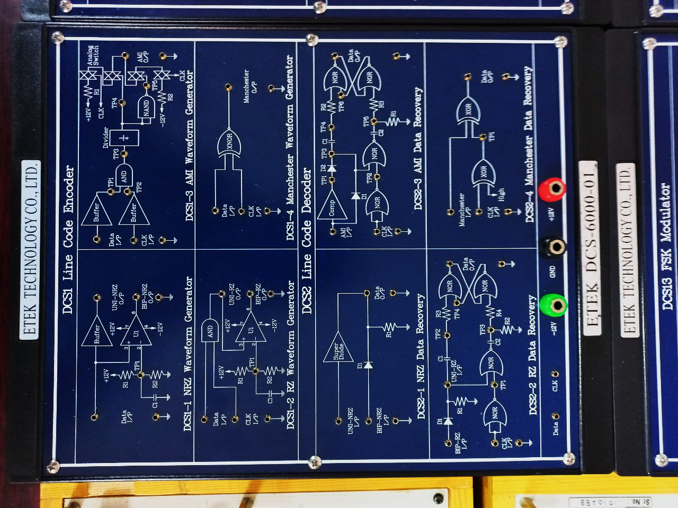 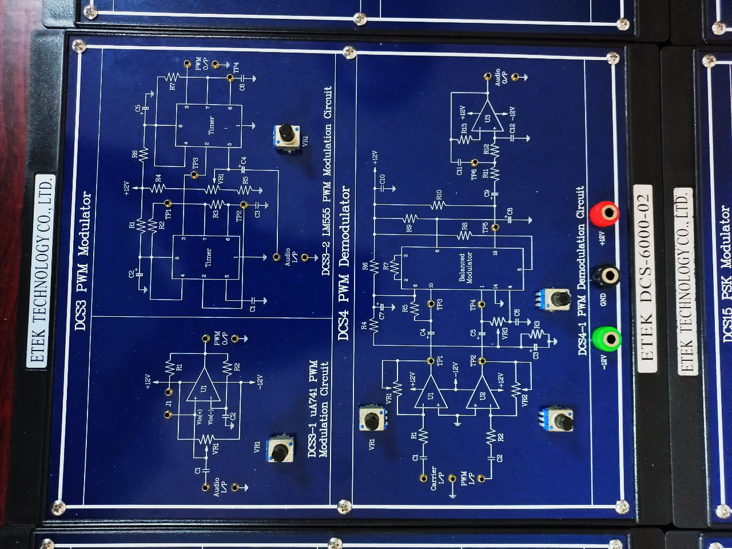

Fig.1.5: Line code encoder & decoder kit Fig.1.6: PWM modulator & demodulator kit

**1.3.5 PCM modulator & demodulator**

PCM stands for Pulse Code Modulation. To study pulse modulation and demodulation, a pulse code modulator and demodulator kit is utilized.

Pulse code modulation is a technique for converting an analog signal into a digital signal. Because PCM is binary, there are only two conceivable states: high and low (0 and 1).

Demodulation can also be used to recover our analog signal.

**1.3.6 DM modulator & demodulator**

Delta modulation is abbreviated as DM. Delta modulation is mostly used for data transport and is an analog-to-digital and digital-to-analog signal conversion technique. A delta modulation system's transmitter circuit consists of a modulator, channel, and demodulator.

There is a Ts delay in the integrator circuit. The output of the integrator is a Ts-delayed staircase approximation.

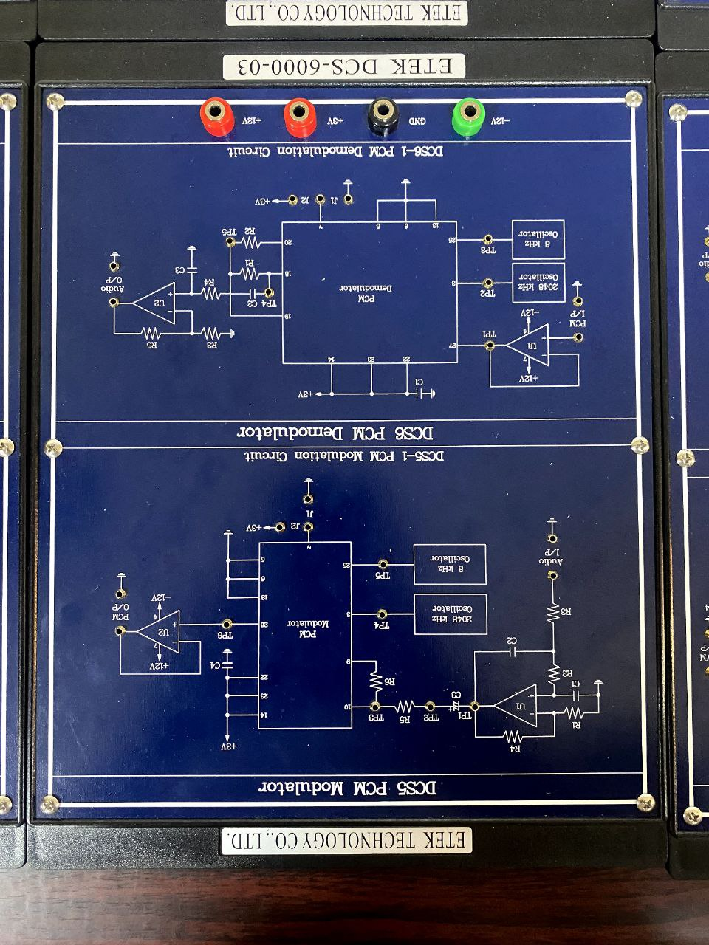 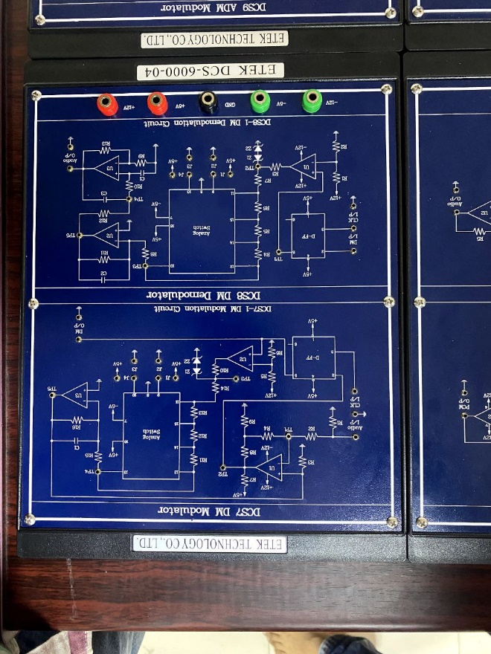

Fig.1.7: PCM modulator & demodulator kit Fig.1.8: DM modulator & demodulator kit

**1.3.7 ADM modulator & demodulator**

ADM stands for Adaptive Delta Modulation.

This is an example of delta modulation in which the step size is not fixed. Rather, when several consecutive bits have the same direction value, the encoder and decoder assume that slope overload is occurring, and the step size becomes progressively larger.

**1.3.8 ASK modulator & demodulator**

ASK is a type of amplitude modulation in which digital data is represented as fluctuations in the amplitude of a carrier wave.

A symbol representing one or more bits is delivered in an ASK system by delivering a fixed-amplitude carrier wave at a given frequency for a specific time length.

For example, if each symbol represents a single bit, the carrier signal could be carried at full amplitude when the input value is 1, but at decreased amplitude or not at all when it is 0.

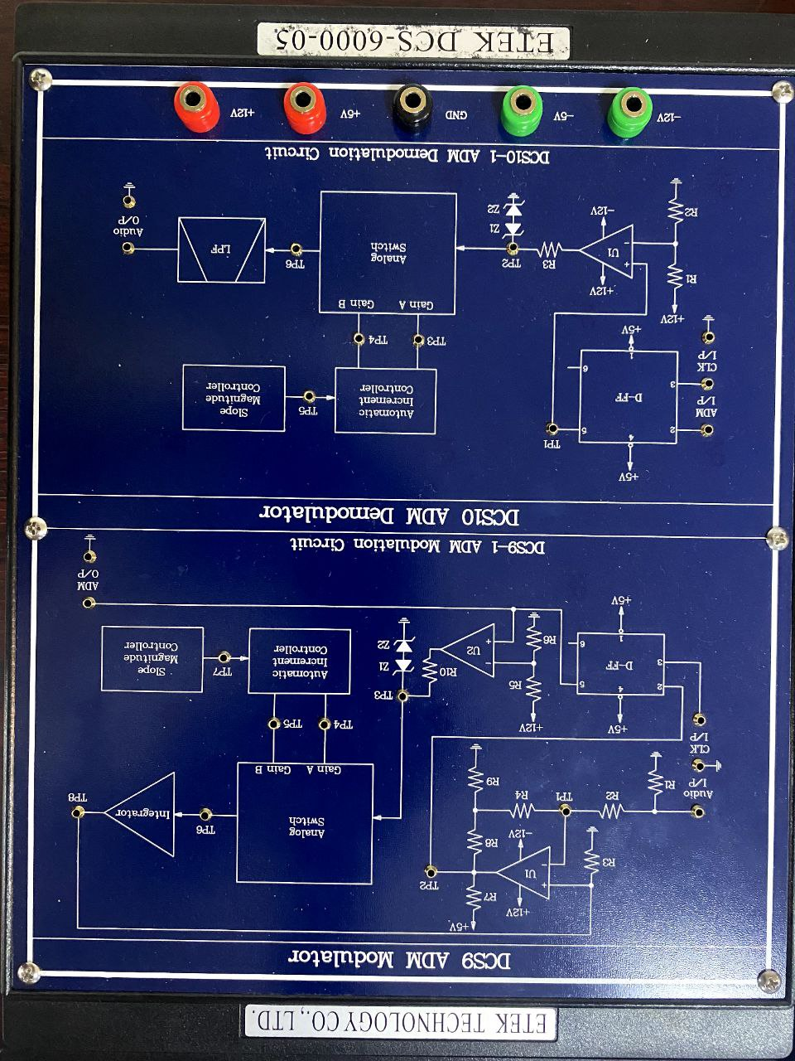 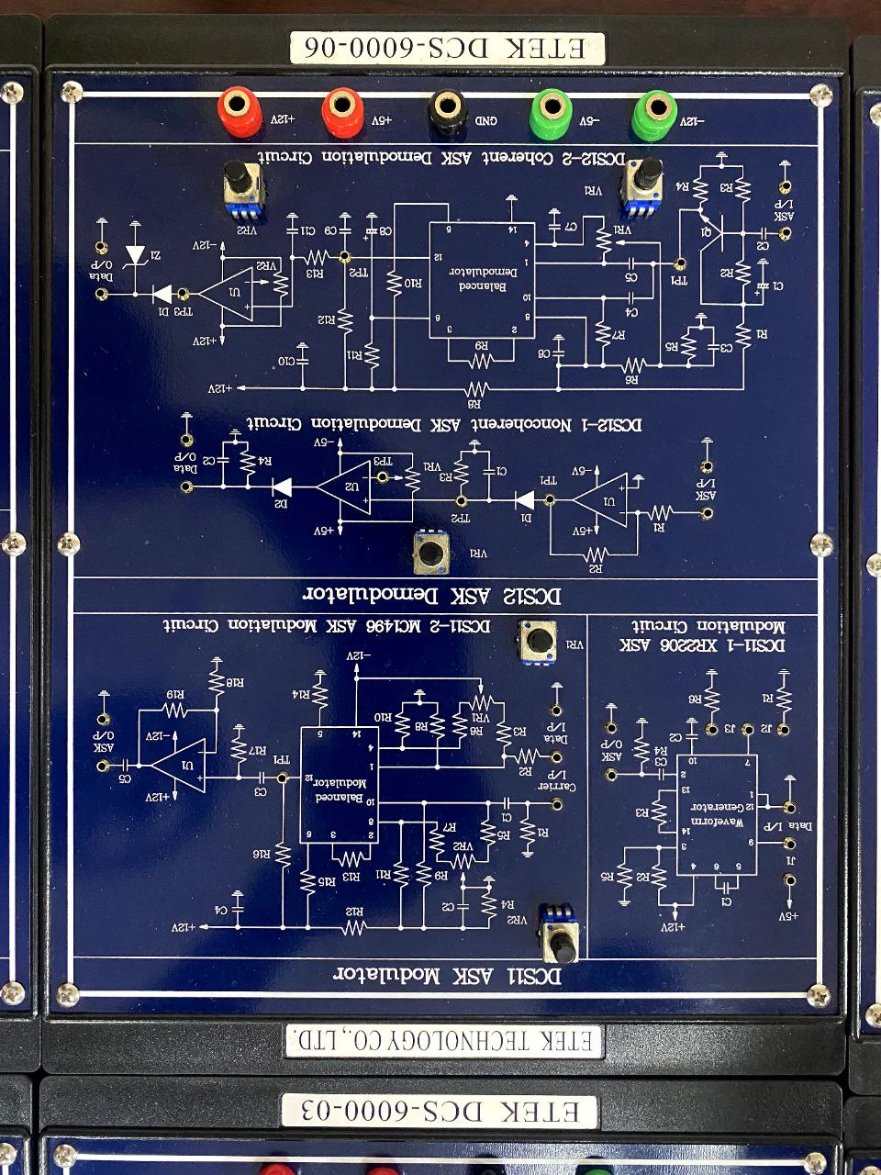

Fig.1.9: ADM modulator & demodulator kit Fig.1.10: ASK modulator & demodulator kit

**1.3.9 FSK modulator & demodulator**

Frequency-shift keying (FSK) is a frequency modulation method that transmits digital information via discrete frequency shifts in a carrier signal.

Binary FSK is the most basic type of FSK (BFSK). To transmit binary data, BFSK employs a pair of discrete frequencies (0s and 1s).

For example, Telemetry, weather balloon radiosondes, caller ID, garage door openers, and low frequency radio transmission in the VLF and ELF.

**1.3.10 PSK modulator & demodulator**

Phase-shift keying is a type of digital modulation that transmits data by varying the phase of a constant frequency reference signal (the carrier wave).

Modulation is achieved by altering the sine and cosine inputs at specific times. It's common in wireless LANs, RFID, and Bluetooth communication.

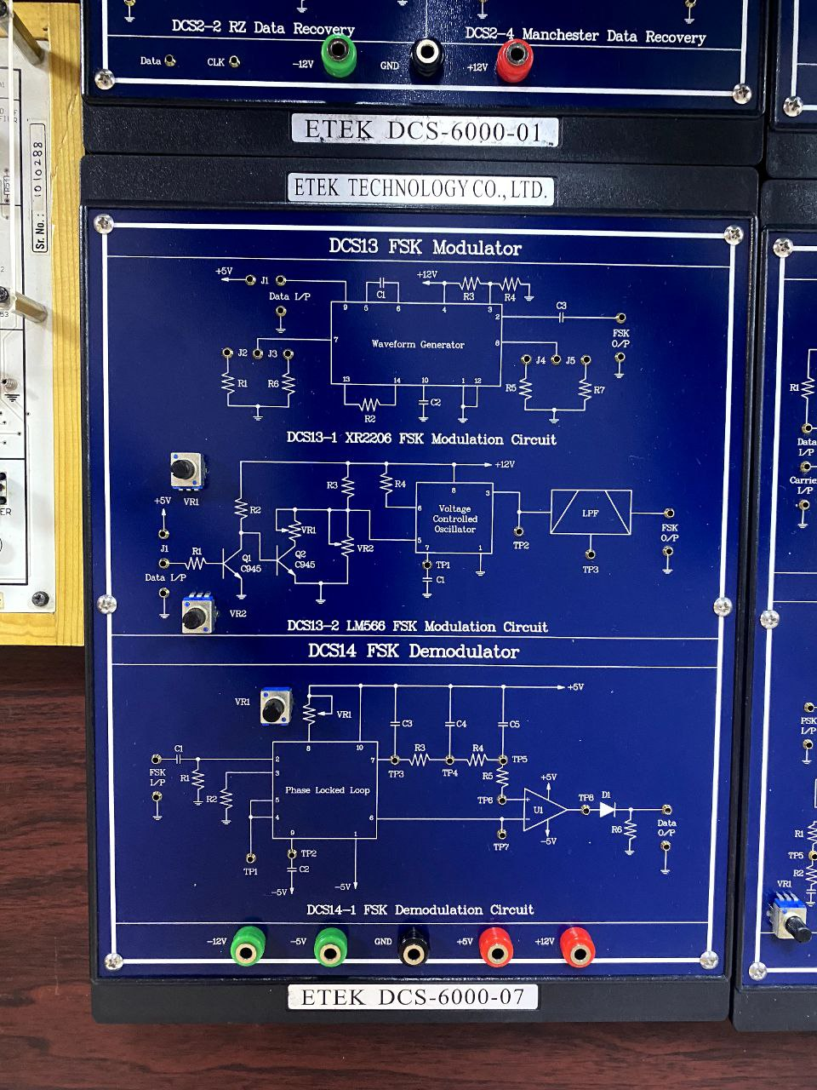 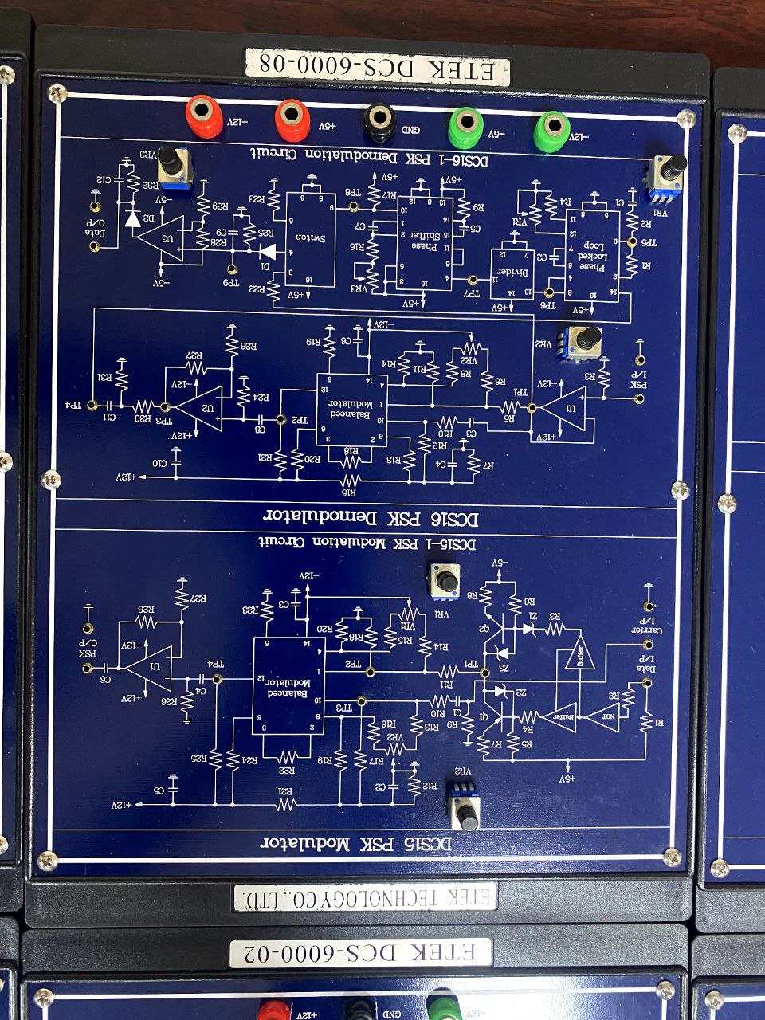

Fig.1.11: FSK modulator & demodulator kit Fig.1.12: PSK modulator & demodulator kit

* 1. **Apparatus**
* Line code encoder & decoder
* PWM modulator & demodulator
* PCM modulator & demodulator
* PSK modulator & demodulator
* ASK modulator & demodulator
* DM modulator & demodulator
* FSK modulator & demodulator
* AM transmitter & receiver
* FM transmitter & receiver
  1. **Discussion & Conclusion**

In this experiment, the functions and purposes of many types of communication laboratory kits were briefly reviewed. Their operation and working principle were also learnt and discussed. Through this experiment, interconnection of these kits was also discussed for better understanding. Thus, the main objective of this experiment was achieved.

* 1. **Reference**
* Book:

Electronic Communication System- George Kennedy

* Links:

https://byjus.com/physics/pulse-width-modulation/

https://www.tutorialspoint.com/digital_communication/digital_com